**Get Help:** 24/7 Trafficking Hotline

1-888-3737-888

Confidential help and information

**Images and Headlines:**

1. #1
   1. **Image-** 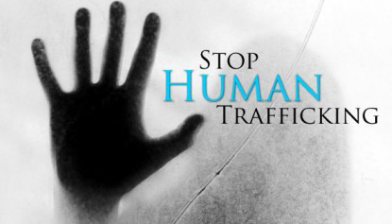
   2. **Headline-** PURPOSE
   3. **Byline:** MANNA Freedom is dedicated to the task of raising awareness of the dangers of sex trafficking and to the prevention of teens and children from becoming victims of sexual exploitation, both domestically and internationally.
   4. **Learn More>** Make expandable window to show rest of content when cursor hovers over Learn more

2. #2

1. **Image-** 
2. **Headline-** GOALS
3. **Byline-**1. To raise awareness about the dangers and extent of human trafficking for sexual exploitation. 2. To engage and develop grassroots leadership dedicated to intervention through prevention and awareness. 3. To resource the fight against sex trafficking and exploitation of children.
4. **Learn More>** Make expandable window to show rest of content
5. #3
   1. **Image-**MANNA Worldwide Video
   2. **Headline-** AFFILILATIONS
   3. **Byline-** MANNA Freedom is a ministry of MANNA Worldwide, a 501(c)3 faith based non-profit organization committed to addressing the nutritional, educational, physical and spiritual well being of children and their families.
   4. **Learn More>** Expandable window to show remainder of content

#4

* 1. **Image-**Pie Chart from MANNA financial page 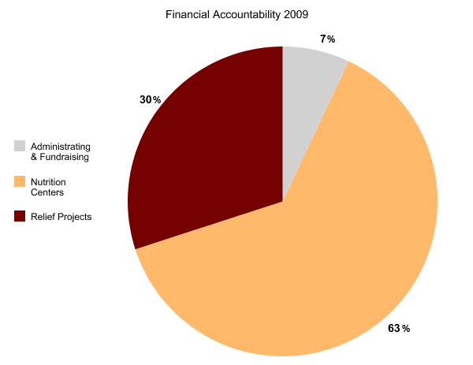
  2. **Headline-**FINANCIALS
  3. **Byline-** MANNA Worldwide and MANNA Freedom are committed to sound and ethical financial practices. Not less than 90% of donations will be used for direct program services.
  4. **Learn More>**link to financials page on MANNA website